**4.1.1 Purpose of the system design**

The objective of the design is to model the system with high quality.by providing value-added services to the bidder and ASTU purchasing and property directorate. Implementing of high quality system depend on the nature of design created by the designer.it provide the complete architectural overview of the proposed system.it is intended to express the significant architectural decisions which have been made on the system. The basic goal of system design is to plan a solution for the problem. Now a day people becoming more dependent on technology and understand the value of time.

**4.1.2 Design goal**

The Design Goals specify the qualities of the system that should be achieved and addressed during the design of the system.

**Performance**

* **Response time:** this refers to the amount of time it takes from an initial user request to receipt of response. Obviously, it must be rapid given today’s user demand.
* **Storage space:** to do work efficiently the processor to be more than 2GB RAM and

HD storage to be more than 100MB

**Dependability**

* **Robustness:** the multi-platform environment of the web places extra ordinary demands on program, because the program must execute reliably in variety of system. The ability to create robust program was given high priority in the design of PHP. It checks your code at a compiled time and run time.
* **Scalability:** more bidders online stand for the increased number of users all making request. The application must be scalable, that is able to process those increasing number just as rapidly as before. This means adding more hardware in proactive way so that correct scaling and architecture is in place and ready to handle the increased load.
* **Security:** ASTU online bidding system should be secured, i.e., by updating system as and for, by using digital signature, encrypted security system and not allow other users or unauthorized users to access data that has no the right to access it. Many people worry about hackers accessing their bank account. Also family or friend could steal your password and access your account information.
* **Reliability:** the information provided by the system is as reliable as it is presented on the web page interface, and this is maintained by the persistent database.

**Maintenance**

Is focused on upgrading an application to ensure it remains productive and cost effective.

* **Availability:** the ability for the application to be usable by its intended users during advertised hours. Availability can be disrupted by any faller that affects a critical component severely enough. By decrease the number of single point of failure in an environment.as long as there is an internet connection and system failure the system
* **Recoverability:** the ability to recover an application environment in the event of system failure or data loss. If a critical component fails and is not recoverable, availability will become non-existent improving maintainability. A related concept, reduce the event of failure, and there- fore can improve availability in the event of failure.

**End User Criteria**

The system should have simple and understandable graphical user interface such as forms and buttons, which have descriptive names. It should give reliable response for each user comment. All the interfaces, forms and buttons are written or designed in a simple language or common language so that the user can access it without any difficult.

**4.3.3 Hardware/software mapping**

In this system design have mainly three hard ware components. The client side, server side and data base side. When the implementation of the system, necessary software loaded to each side hardware components network should be installed b/n each side. Then each sub system software are will be assigned and configured to the mapped hardware. then the local area network will be connected to the internet and the system will be functional

**4.3.4. Persistent data management**

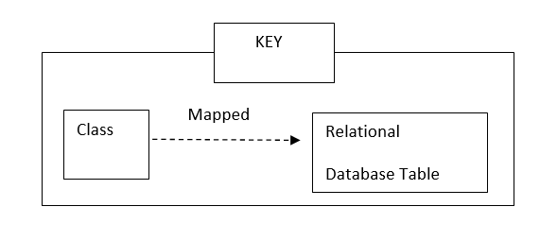



Figure 1 bid mapping



Figure 2 form mapping



Figure 3 user mapping



Figure 4 bidder mapping



Figure 5 service mapping



Figure 6 bid document mapping



Figure 7 approval mapping



Figure 8 advert mapping

**4.3.5. Component diagram**



Figure 9 component diagram

**4.3.6. Deployment diagram**



Figure 10 deployment diagram

**4.3.7. Database design**

